Table of Contents

The Nutcracker, history and background p. 1

Story p. 2

Curriculum standards p.3
Curriculum standards p.4

Teaching activities p. 5-7

Student behavior at a
live performance p. 8

This Teachers guide is presented by

Ballet Arts, Inc. Jackson, Tn.
731-668-7353

The Nutcracker is a ballet. (A ballet is an artistic performance that uses movement/dance to tell a story, express an idea, or relate beauty. Most of the time a ballet is performed with music. Scenery and costumes are used to enhance the story. There are no spoken words in a ballet.)

History of the Nutcracker
The ballet is an adaptation of the story by E. A. Hoffman. Choreographer Marius Petipa worked in close collaboration with composer Peter Tchaikovsky in the composition of the score and development of the ballet. Together they altered the relationship between the music and ballet, creating first the serious dramatic music to support the action taking place in the ballet. Unfortunately, before completing the ballet Petipa became ill and his assistant Lev Ivanov completed the choreography. I t was first presented in St. Petersburg in December 1892. In 1954 the New York City Ballet presented their first version with choreography by George Ballanchine. Today The Nutcracker is a holiday tradition for many families in many cities throughout the world.

Peter Tchaikovsky, The Composer
Peter Ilyich Tchaikosky wrote the music for the “Nutcracker” in a short two-month period in 1891. He was a stickler for accuracy. He imagined and heard a composition in his mind as if an orchestra was playing it. While he was writing the musical score, one of his friends sent him a crate of children’s instruments. He used them in the ballet to create a special atmosphere for the ballet

The Nutcracker is a ballet that tells a story.
The characters in the story are:
- UNCLE DROSSELMEYER...

HIS NEPHEW........
- FRAU SILBERHAUS....
- MAYOR SILBERHAUS....
- CLARA, THEIR DAUGHTER....
- FRITZ, THEIR SON...
- CHILDREN
- MECHANICAL DOLLS:
- MICE.............
- NUTCRACKER PRINCE....
- SOLDIERS.......
- MOUSE KING......
- SNOW QUEEN......
- SNOW KING.......
- SNOW FLAKES....

This teacher guidebook is produced by the Ballet Arts, Inc. for Arts Education. In order for students to receive the full benefit of understanding the arts, they must not only attend the event or exhibition, but also engage the work with curiosity and artistic awareness so that it becomes a learning experience. This document will help you prepare students to attend the selected event or exhibition with an understanding of the elements of the particular art form, its themes, its history, and the way it relates to other subjects. Also included are special activities, which allow students to engage in their own creative processes in regards to this selected arts event.

The Nutcracker
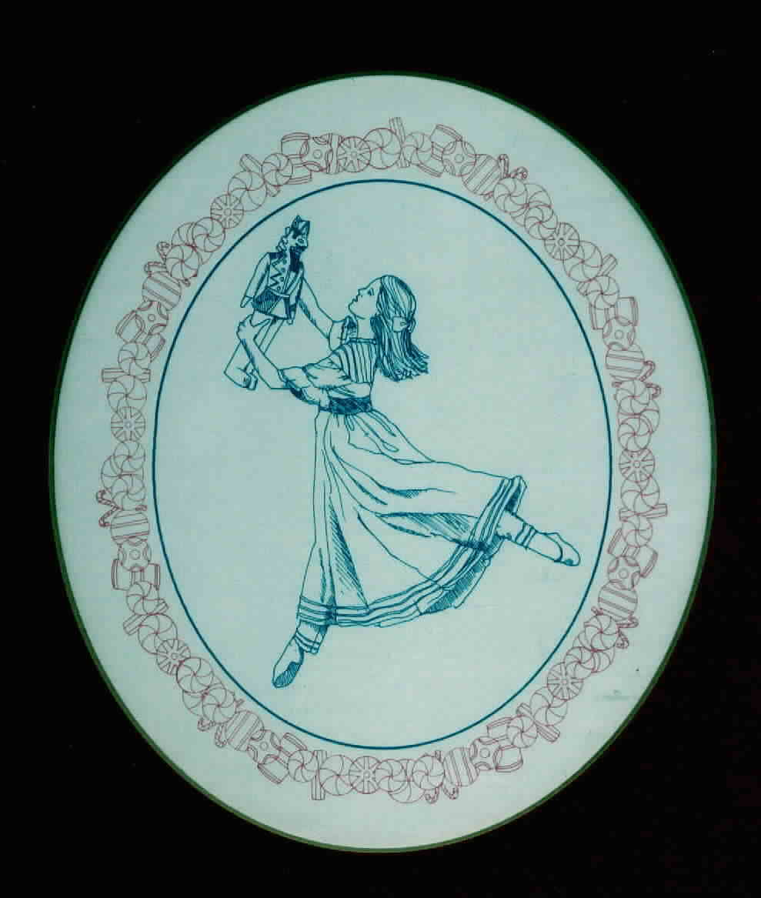
Major Musical Themes
Act I
Children’s Dance –March
Grandfather’s Dance- ¾ Heavy rhythm
Tree Grows-Wave after Wave of Orchestra
The Battle-Fanfares of Energy
Dance of the Snowflakes-Whirling Waltz
Act II
Waltz of the Flowers-Familiar Waltz
Pas de Deux – Adagio
Tarantella
Sugar Plum solo
Coda
The Nutcracker Ballet Story
Act I
The Party, the Battle and Snowflakes

The ballet opens with families arriving at the Silberhaus’ home for a Christmas Eve party. The festivities begin and Clara and Fritz, the children, dance and play with their friends.

Suddenly Uncle Drosselmeyer arrives with his nephew. He is Clara’s godfather and brought three life size dolls to dance for the children and parents alike.
Drosselmeyer gives Clara a, gift, a Nutcracker Doll. Clara dances
a lullaby with the other girls only to be interrupted by the boys.
Fritz, in a fit of jealousy over Clara’s
gift, grabs the nutcracker from her, dropping it and breaking it.
Clara is heartbroken but Drosselmeyer assures Clara that he will fix it. The celebration continues until it is time for the guests to leave and the children to be in bed.

While Clara sleeps, things begin to
happen in the living room. Drosselmeyer
weaves his magic. The Christmas tree grows and giant mice and toy soldiers battle right in front of Clara’s eyes.

The Mouse King arrives and it seems like the battle is lost until the Nutcracker Soldier arrives and joins the fight. During a battle between them, Clara throws her shoe at the Mouse King, killing him. The Nutcracker is transformed into a prince.
The Nutcracker Prince takes Clara on a journey through the land of the snowflakes where the Snow Queen and King dance for them. They soon find themselves in the Kingdom of Sweets.

Page 2 CAE

Act II
The Kingdom of Sweets.

Clara and the Prince arrive in the Kingdom of the Sweets. She tells the Sugar Plum Fairy about the battle between the mice and soldiers. The Sugar Plum Fairy is grateful to Clara for saving the nutcracker and honors her with a celebration. She is entertained with a series of dances in her honor. Each dance represents a dessert.
Reed Flutes represent German Marzipan
Russian Dancers represent Candy Canes
Spanish Dancers represent Hot Chocolate
Arabian Dancers represent Coffee
Chinese dancers represent Tea
Mother Ginger and her troupe represent Bonbons
Dew Drop dances with her Flowers
The Sugar Plum Fairy and her Cavalier dance the Pas de Deux( pronunciation-pah-duh-duh)( a dance for a male and female).

Soon all the characters say good-bye to Clara as she begins her journey home.

Curriculum Connections
Page 3 CAE
Tennessee English Language Arts Standards
Primary – K-3
Anchor Standards for Reading
Integration of Knowledge and Ideas
7. Integrate and evaluate content presented in diverse media and formats, including visually and
quantitavely, as well as in words.

Anchor Standards for Writing
Text Types and Purposes
3. Write narratives to develop real or imagined experiences or events using effective technique, well
-chosen details, and well-structured event sequences.
Production and Distribution of Writing
4. Produce clear and coherent writing in which the development, organization, and style are
appropriate to task, purpose, and audience.
Range of Writing
10. Write routinely over extended time frames and shorter time frames for a range of tasks, purposes,
and audiences.

Anchor Standards for Speaking and Listening
Comprehension and Collaboration
- Prepare for and participate effectively in a range of conversations and collaborations with diverse partners, building on others’ ideas and expressing their own clearly and persuasively.
- Integrate and evaluate information presented in diverse media and formats, including visually, quantitavely, and orally.
Presentation of Knowledge and Ideas
5. Make strategic use of digital media and visual displays of data to express information and
enhance understanding of presentations.

Music Standards

3.2 Improvise a developmentally and/or grade-appropriate rhythm using body percussion, pitched, and/or non-pitched
instruments.
4.1 Create a rhythmic composition.
8.1 Experience and recognize elements of music as they relate to other art disciplines.
8.2 Examine ways in which music interrelates with other academic disciplines.
9.1 Recognize, describe, and perform music of various cultures and historic periods.

Tennessee English Language Arts Standards
Elementary – 4,5

Anchor Standards for Reading
Integration of Knowledge and Ideas
7. Integrate and evaluate content presented in diverse media and formats, including visually and
quantatively, as well as in words.

Anchor Standards for Writing
Text Types and Purposes
- Write narratives to develop real or imagined experiences or events using effective technique, well-chosen details, and well-structured sequences.
Production and Distribution of Writing
- Produce clear and coherent writing in which the development, organization, and style are appropriate to task, purpose, and audience.
Range of Writing
10. Write routinely over extended time frames and shorter time grames for a range of tasks,
purposes, and audiences

Anchor Standards for Speaking and Listening
Comprehension and Collaboration
- Prepare for and participate effectively in a range of converations and collaborations with diverse partners, building on others’ ideas and expressing their own clearly and persuasively.
- Integrate and evaluate information presented in divers media and formats, including visually, quantatively, and orally.

Music Standards
3.2 Improvise a developmentally and/or grade-appropriate rhythm using body percussion, pitched, and/or non-pitched instruments while keeping a steady rhythm.
8.2 Investigate and compare ways in which music interrelates with other academic disciplines
9.1 Classify and/or perform music of various cultures and historical periods.

Page 4 CAE

Tennessee English Language Arts Standards
Middle Grades 6-8
Anchor Standards for Reading
Integration of Knowledge and Ideas
7. Integrate and evaluate content presented in diverse media and formats, including visually and
quantitavely, as well as in words.

Anchor Standards for Writing
Text Types and Purposes
3. Write narratives to develop real or imagined experiences or events using effective technique, well
-chosen details, and well-structured event sequences.
Production and Distribution of Writing
4. Produce clear and coherent writing in which the development, organization, and style are
appropriate to task, purpose, and audience.
Range of Writing
10. Write routinely over extended time frames and shorter time frames for a range of tasks, purposes,
and audiences.

Anchor Standards for Speaking and Listening
Comprehension and Collaboration
- Prepare for and participate effectively in a range of conversations and collaborations with diverse partners, building on others’ ideas and expressing their own clearly and persuasively.
- Integrate and evaluate information presented in diverse media and formats, including visually, quantitavely, and orally.
Presentation of Knowledge and Ideas
5. Make strategic use of digital media and visual displays of data to express information and
enhance understanding of presentations.

Music Standards

3.2 Create a non-notated rhythmic variation to a given short rhythmic pattern.
7.2 Evaluate the quality and effectiveness of music performances.
8.1 Explore the relationship between music and other art disciplines.
8.2 Explore the relationship between music and other academic disciplines.
9.1 Explore the characteristics of music genres and styles within their historical and cultural settings.

Curriculum Connections

Orchestrating the Dance

TLW demonstrate that both sounds and movements can form rhythmic patterns.

Warm-up: Read a simple sentence to the class in a monotone. Read it again adding different rhythmic patterns to your voice each time. Vary the speed, tone, or energy level of your voice. Clap the rhythmic patterns. Discuss which patterns are more interesting and why.

Teaching Activity:
1. Invite students to form a circle. One at a time, have each student speak their own mane in a rhythmic pattern of their choice. Ask the group to echo each person.
2. Have each student speak their name and clap the rhythmic pattern. Encourage them, to explore different patterns. Again, have the group echo their pattern.
3. Have each student add a movement pattern to their rhythmic pattern. Encourage them to use different body parts. Again, echo the rhythm and the movement.
4. Invite students to get in pairs. Give each student pair a simple sentence about a character in The Nutcracker. Students create a rhythmic and movement pattern to their sentence.
5. Have the pairs take turns being the “orchestra” (clapping the rhythm) and the “dancer”, dancing the rhythm.

Closure:
Discuss other rhythmic patterns that are a part of daily activities. Examples: the rhythm of the school bus, brushing teeth, eating, walking to class, running to class, watching television, skipping rope, bouncing a ball, etc.

Dance of the Toys
TLW imagine their favorite toys coming to life and explore the way these toys might move.

Warm-Up: Discuss the puppets Drosselmeyer brings to life in the first act. Describe how they move, focusing on the use of adjectives. List the descriptions on the board. Try to move in the same way.
What toys come to life during the battle scene in Clara’s dream sequence? How did they move? Try moving the same way.

Teaching Activity:
1. Have the students name some of their favorite toys. Discuss what movement each toy would be able to make is it came to life. Examples: ball – bouncy, puppet – stiff movements, rag doll – floppy and loose.
2. Name different toys and let the children explore the different movement possibilities of each toy.
3. Each child is to transform themselves into a particular toy and create a “movement sentence” as that toy. Begin with a still shape representing a toy, add 8 traveling motions (walking, changing levels, skip on a diagonal, twist and turn in a circle, etc.), add a jump, and add an ending shape.
4. Have each child begin in their beginning shape, wind them up, allow them to unwind in their movement.
5. Repeat activity faster or slower.

Closure:
Ask the children which toys was their favorite to perform. Which were their favorite to watch? Which were easier to perform? Which were harder? How did tempo change affect the toy?

Follow-up Activity: Choose a piece of music for the toys to dance to. When the music is played, have all of the toys come to life at the same time. When the music stops, have them freeze in a shape like their character.
Page 5 CAE
T
E
A
C
H
I
N
G

A
C
T
I
V
I
T
I
E
S

T
E
A
C
H
I
N
G

A
C
T
I
V
I
T
I
E
S

Page 6 CAE
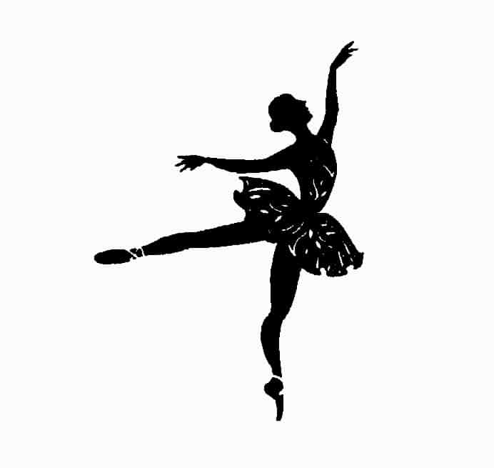

Emotions Through Motion

TLW Express a feeling through movement.

Materials needed: Several different emotional situations written on pieces of paper. Ex: angry with brother, lonely for friend.

Warm-up: Discuss the different situations in Nutcracker in which the characters feelings were expressed through their movement. Using many adjectives, describe various feelings and the movements that coincide with each feeling. Example: anger-stamp, explode; fear-shiver, tremble, sad- slow, heavy, downward movements.

Activity:
1. Call out different emotions and ask students to express the feelings. Encourage the students to explore different movement qualities as teacher calls them out.
2. Invite students to get into “pairs”. Let each pair draw an emotion situation to “dance”. Remind them to have a beginning, middle, and an end to their dance.
3. Ask each pair to perform their “dance” for the rest of the class. Have the observers try and determine the emotion situation from the movement.

Closure:
Discuss the various movements each group selected for it’s situation and how these movements conveyed the emotion to the audience.
Discuss ways we all move in relation to how we feel at a particular moment.

Variation: Do the same exact movement but with a different felling. How does this change the movement? For example, stamp your foot in anger, and then stamp it with joy. Does your posture change? Does the placement of your head and arms in the movement change?

A Personal Story

TLW write their own Nutcracker stories based on their Christmas experiences.

Warm-up: Engage students in a conversation about their own holiday celebrations.
- Does their family have a holiday gathering?
- How do they dress?
- Are music and games involved in the festivities?

Activity:
1. Students write their own versions of Nutcracker. Ask them to imagine they are Clara (or a male version of Clara) and the party takes place in their home. What might occur at the party that could be transformed into a character and or a place during a dream.
2. Illustrate a particular scene from their story.
3. Working in groups, act out a part of their story with movement only- no voices.

Closure:
Ask students to share their stories with the class. Let the students take the stories home and share them with their parents. Ask the parents to share a childhood holiday story.

Insert picture, clipart or text here!

Compare and Define

TLW describe the differences between two dances.

Warm-up: Discuss with students the different types of dances (solo, duets, corps) before the performance

Activity: Using the program as a guide, TLW write descriptions of each dance using musical terms-tempo, dynamics, meter, and tone color to compare and contrast two dances.
History and Movement

TLW move to the beat using simple dances to relate music with geography.

Activity: Using a globe or map, point out France,. Read Ballet Beginnings to students and explain. Demonstrate plie and releve. TLW demonstrate and practice moving from releve to plie.

Closure: TLW will move on the beat doing releve, then plie to one of the selections.

Contrasts

TLW recognize the difference in mood of contrasting pieces of music.

Warm-up: Children observe while the teacher tosses a balloon in the air and allows it to float to the ground.

Activity: Have children toss their balloons in the air and observe as it floats to the ground. Duplicate the movement with their bodies. Do several times. Ask children to keep their balloons in the air while maintaining their own floating, sustained movement. Use different body parts to keep the balloon in the air. Come to a soft slow ending.

Activity 2:TLW move on the beat to “March”. Teacher directs movement (i.e. pat knees, clap, tap ) as music plays. Students pattern.

Closure: Discuss differences between movements.

Page 7 CAE
T
E
A
C
H
I
N
G

A
C
T
I
V
I
T
I
E
S

Be a Great Audience

TLW demonstrate appropriate audience behavior.

Activity: Teacher will read and discuss “Student Behavior at a Live Performance”.

Closure: After performance, TLW state specific example of appropriate behavior.

