Curricular Expansion through Art:
Puppetry and Folklore
An exploration in Visual Arts and Drama for any age group

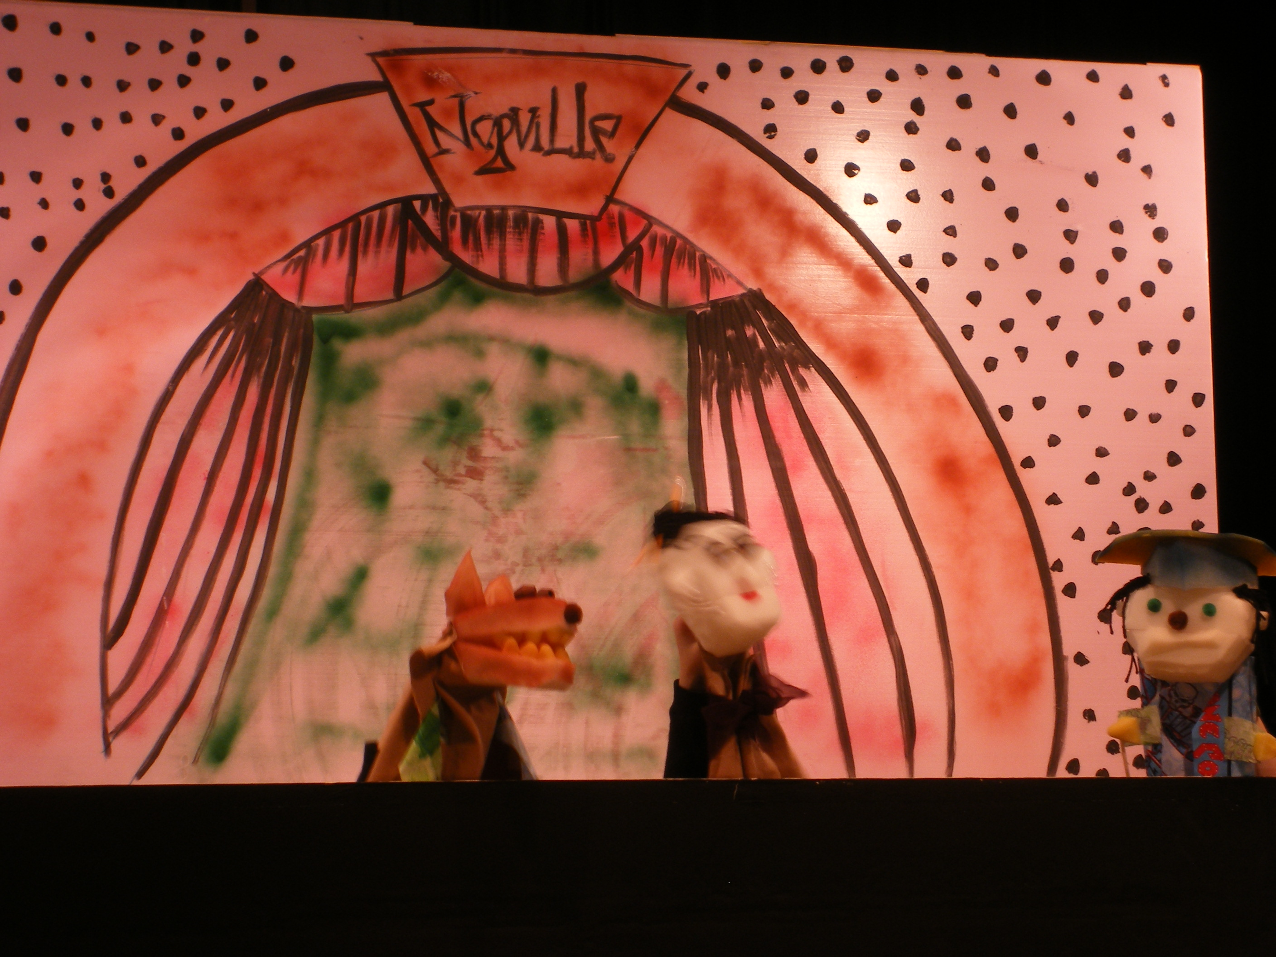
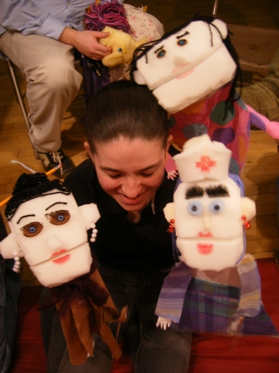

Curricular Expansion through Art: Puppetry and Folklore
Curricular Disciplines: Language Arts, History, Social Studies
Art Disciplines: 2 & 3 Dimensional Visual Art and Theater
Grade Level: Adaptable for 2nd through 5th grade
Length of lesson: 5 days (minimum 5 one hour sessions)
Essential Questions: How do we present the written word orally, expressing emotion and feeling to communicate?
How can we use our skills and understanding of art, movement, and
Drama to tell a story that entertains and teaches?
How do we bring the written word into a three dimensional medium?
How do we work in a collective effort to present a positive outcome to an audience?

Standards Addressed:
Visual Art –
Media, Techniques, and Processes 1.0
1.1 Demonstrate an understanding of a variety of tools and materials used to create a
work of art in 2 and 3 dimensions.
1.2 Develop skills in a variety of techniques and processes to produce original works of
art that reflect ideas, concepts, symbols and themes.

Structures and Functions 2.0
2.1 Develop an awareness of the elements of design and the principles of composition
through their application.
2.2 Create and evaluate art works that exhibit various sensory and expressive qualities.
2.3 Develop an awareness of the function or intrinsic purposes of works of art.

Evaluation 3.0
3.2 Experiment with subject matter, symbols, and ideas to create meaning in their own
artworks.

Reflection and Assessment 5.0
5.2 Appraise the characteristics and merits of their work and the work of others.

Theater –
Character Acting 2.0
2.2 Use imagination to form and to express thought, feeling and character.
2.5 Employ movement to express thought, feeling and characterization.
2.6 Employ vocal techniques to express thought, feeling and characterization.

Scene Design 3.0
3.3 Experiment with creating costumes, properties and scenery for improvised or
scripted scenes.
3.4 Utilize safety procedures when creating design elements.

Theatrical Presentation 6.0
6.2 Examine dramatic media as a forum for the synthesis of all of the arts.
6.3 Integrate other art forms into the creation of dramatic projects.

Program Components:

Task 1
Artist will lead the class in a puppet-building workshop, following this outline:

1) Discuss the story line and the characters’ relationships. Discuss physical appearances that show "character" leading to the construction of puppet characters.
2) Stress details (compare characters)
3) Begin construction of puppets, sculpting heads (using additive and subtractive
sculpting)
4) Complete figure with body and details
5) Add controls
6) Build any props for the puppets

Task 2
Artist will lead the class in a set-design workshop, following this outline:
1) Introduce overall concept of set design, scale, and proportion
2) Discuss and draw scenery for their play
3) Demonstrate color mixing
4) Layout and bulk paint

Task 3-4
Artist will lead the class through rehearsals for the puppet-play, following this outline:
1) Talk about and demonstrate stage directions upstage down stage etc.
2) Begin blocking puppet movement on stage.
3) Finish blocking puppet movement on stage.
4) Bring all the groups together in the performance space and let each group perform for
the rest of the groups, at least one full run through.
5) Work out logistics of getting puppeteers and scenery on and off stage.

Task 5
Artist will prepare students for their performance of the puppet play.
Students will perform puppet-play.
Artist will lead class in a reflection on the experience of their performance.

This Lesson Plan was prepared by:
Clarissa L. Lega
Artistree, Inc. / Wood & Strings Theatre
907 Shady Circle
Centerville, TN 37033-1164
931-729-9911

