Ballet Memphis presents
THE NUTCRCKER

About the composer:
Peter Ilyich Tchaikosky was commissioned by the St. Petersburg Opera to write the music for The Nutcracker in 1891. Unhappy with the initial piece, he set it aside until the legendary choreographer, Marius Petipa, approached him. Petipa presented Tchaikovsky with an exact scenario for the ballet, which included the rhythm, tempo, and length of each dance. Tchaikosky composed the music for three full-lengths ballets, Swan Lake, Sleeping Beauty and The Nutcracker.
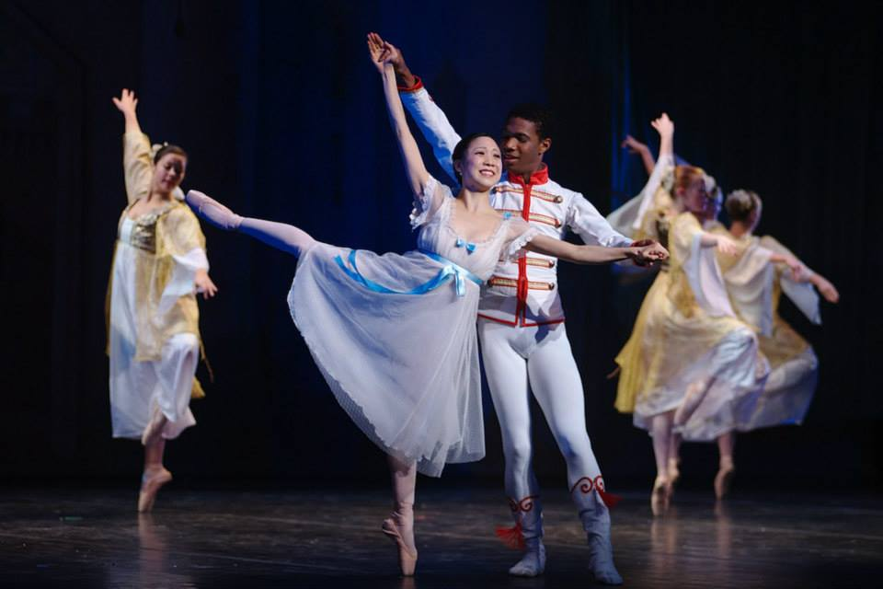About the choreographers:
STEVEN MCMAHON (Artistic Associate) has created more than a dozen ballets for Ballet Memphis, including his first full-length ballet, Wizard of Oz as well as Soul Selects Her Own Society, Confluence, The Royal We and Peter Pan. His other new ballets for Ballet Memphis include Carnival of the Animals, Romeo and Juliet and Cinderella. Steven also has choreographed many original works including The Lovely Story of Us, which was performed in Helsinki, Finland, at the International Ballet Competition, and two of his works, Being Here With Other People and Confluence, have been performed at the Spring to Dance Festival in St. Louis. His works have been performed at Organizacion Para La Artes in Guatemala and at other venues around the nation. His first work, What Your Soul Sings, premiered at Ballet Memphis’ Interiorworks. Steven, who is originally from Glasgow, Scotland, is also a dancer with Ballet Memphis and joined after completing his training at The Ailey School in New York City.
JANET PARKE (Choreography, School Principal and Junior Company Director) is now in her 33rd season with Ballet Memphis. Parke trained at the Fort Wayne Ballet Academy, Texas Christian University and the Atlantic Foundation for the Performing Arts in Fort Lauderdale, Fla., under the direction of Ruth C. Petrinovic and Brenda Gooden. She has taught all levels of ballet school at the Atlantic Foundation for the Performing Arts, the Fort Wayne Ballet Academy, Rhodes College, St. Mary’s Episcopal School and Ballet Memphis. She also has published To The Pointe, a guide to the fitting, care and wear of pointe shoes. Parke has choreographed more than a dozen ballets for Ballet Memphis including Coppélia, A Midsummer Night’s Dream, Nutcracker and Starlight. In addition to serving as school principal and teaching in the Ballet Memphis School, Janet directs and choreographs the Junior Company.
JOSEPH JEFFERIES (Choreographer) said farewell to Ballet Memphis as a dancer at the end of the 2005-2006 season to join Les Ballets Trockadero de Monte Carlo. While with Ballet Memphis, he performed a wide range of roles including Prince Siefried in Swan Lake, Albrecht in Giselle, Jerry Lee Lewis in Lila York’s Breathless, as well as lead roles in Trey McIntyre’s Naughty Boy and Grace, and Robert Battle’s Facing. Joseph also choreographed numerous ballets for Ballet Memphis such as The Little Mermaid in 2002 and Beauty and the Beast in 2006. He also has choreographed for Miami City Ballet’s workshop performance, Peoria Ballet and Ballet Yuma. Joseph was selected to present his ballet, Cupid Revealed, during Ballet Builders 2006 in New York. Ballet Builders is a highly competitive showcase presented by New Choreographers on Point, an organization that seeks to foster emerging ballet choreographic talent. Joseph also danced with Ballet Arizona and Pittsburg Ballet Theatre.

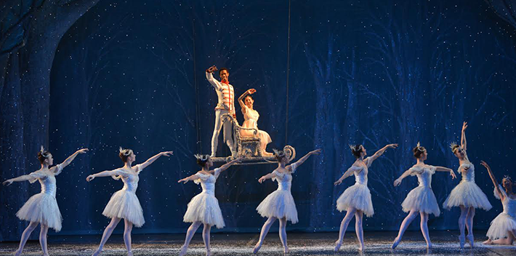
How well do you know the story of The Nutcracker?
- The original ballet takes place in 1850’s in which if the following countries?
Italy France Germany Sweden
- _____________________ composed several ballets including Swan Lake, Sleeping Beauty and The Nutcracker.
Stravinsky Mozart Chopin Tchaikovsky
- Clara (called Marie in some versions) receives a Nutcracker as a gift. Who gives her this gift?
Grandfather Cousin Mother Drosselmeyer
- In Clara’s dream she is taken to:
The Enchanted Forest The Kingdom of Sweets A Toy Shop
- How many seasons have Ballet Memphis performed The Nutcracker?
25 29 30 22
THE NUTCRACKER SYNOPSIS

Act I: Scene I: A Christmas Eve Party at the Stahlbaum’s house.
Final preparations at the Stahlbaum house are being made for their Christmas Eve party. The Stahlbaum children, Clara and Fritz, wait anxiously for the guests to arrive. Soon all are present, the tree is lit and the festivities begin. Suddenly the mysterious Herr Drosselmeier arrives. He is Clara’s godfather and has brought several toys and gifts for the children, including 3 life-size dancing dolls, Harlequin, Columbine and Pierrot. After the dolls are finished dancing, he gives Clara a special gift, a Nutcracker doll. In a jealous fit, Fritz grabs the toy from Clara and breaks it. Drosselmeier ties his handkerchief around the broken Nutcracker and promises to fix it. The dancing and celebrating continue until it is finally time for the guests to go home. Clara places the Nutcracker in the parlor and sleepily goes off to bed.

Scene II: The Battle
Clara sneaks back into the parlor to check on her beloved Nutcracker. She falls asleep and dreams that she is confronted by huge scary mice. She is frightened by the darkness, but Drosselmeier appears, temporarily frightening the mice away, and he changes the Nutcracker into a life-sized doll. Drosselmeier then magically transforms the room into a size that dwarfs Clara. Suddenly the mice return and a huge battle ensues. Unable to handle the mice alone, the Nutcracker enlists the aid of the toy soldiers. When the Mouse King arrives, it seems the battle is lost. In desperation, Clara kicks him to distract his attention, and the Nutcracker is able to slay him. The Nutcracker is magically transformed into a handsome prince.

Scene III: The Land of Snow

The Nutcracker takes Clara on an incredible journey to the Kingdom of Sweets. To get there they must first pass through a beautiful snow laden forest where Nutcracker and Clara dance amidst the snowflakes.
Act II: The Kingdom of Sweets
Clara and the Nutcracker Prince arrive at the Kingdom of Sweets and tell the Sugar Plum Fairy of their battle with the Mouse King and his minions. The Sugar Plum Fairy is grateful to Clara for saving the Prince and presents the following dancers to perform in her honor. Spanish dancers present a fast and fiery dance. A trio, danced by Arabian dancers, is sensual and acrobatic. The Chinese dancers bring Clara a lively dance. The Mirlitons dance in a group with their wee lambs. Mother Ginger dances with her Polichinelles. The Russians dance an athletic variation, and the DewDrop Fairy leads the Waltz of the Flowers.
Just when Clara felt she had seen all the beautiful dances in the Kingdom, the Sugar Plum Fairy and her Cavalier dance an elegant pas de deux. Soon they are joined by all of the characters in the Kingdom to dance a lively finale. They all bid Clara farewell.

After attending the ballet:
Write a review:
What were some of the memorable moments in the ballet that caught your attention and contributed to the storyline? How were the characters portrayed through dance? Describe the relationship of the music to the dance and story.

Write a letter to the company:
They enjoyed hearing from the audience. Include a drawing of your favorite dance.

Imagine: The Night the Toys Became Real
In Act 1 Herr Drosselmeyer entertains the children with life-size dancing dolls. Later, Clara dreams that her Nutcracker has become life-size and battles the life-size toy soldiers and mice. How might a toy soldier dance? A mouse? Can you imagine your own toys becoming real? How would they move? Can you create a story about the night your about the night your toys came alive? Draw a picture of your story. Can you create a dance about the night your toys came alive?
*Full curriculum upon request*
Nikki Lewis 901.214.2407
nlewis@balletmemphis.org

Visit our web page at:
www.balletmemphis.org

Before coming to the performance:
Read the story:
In classical ballet the story is told through movement, and clearly tells the story it is always best to be familiar with the plot. A synopsis of the story is found on page 3 of this guidebook. Also, many wonderful books have been written and several include a story tape weaving Tchaikovsky’s music and the narration. Check the local library or the children’s area of the book store.
Listen to Tchaikovsky’s music:
Listen to these different scenes from the story.
- The Lullaby as the girls rock their dolls to sleep
- The boys running through with their instruments
- The arrival of Drosselmeyer
- The dance of the life-size dolls
- The ballet scene between the soldier and the mice
- The dance of snowflakes
- The individual divertissement, the dances from all over the world, in the second act
Holiday Memory Activities:
In Act 1 of the ballet we join the Stahlbaum family and their friends in a holiday celebration that includes traditional activities such as the lighting of the tree, the anticipation of gifts, music and dancing. Write a description of your favorite holiday memories.

Read the story:
T
E
A
C
H
I
N
G

A
C
T
I
V
I
T
I
E
S

In classical

