Ballet Memphis presents
GISELLE

About the composer:
Adolphe Charles Adam (24 July 1803 – 3 May 1856) was a French composer and music critic. A prolific composer of operas and ballets, he is best known today for his ballets Giselle (1841) and Le corsaire (1856, his last work), his operas Le postillon de Lonjumeau (1836), Le toréador (1849) and Si j'étais roi (1852) and his Christmas carol Minuit, chrétiens! (1844), later set to different English lyrics and widely sung as "O Holy Night" (1847). Adam was a noted teacher, who taught Delibes and other influential composers.
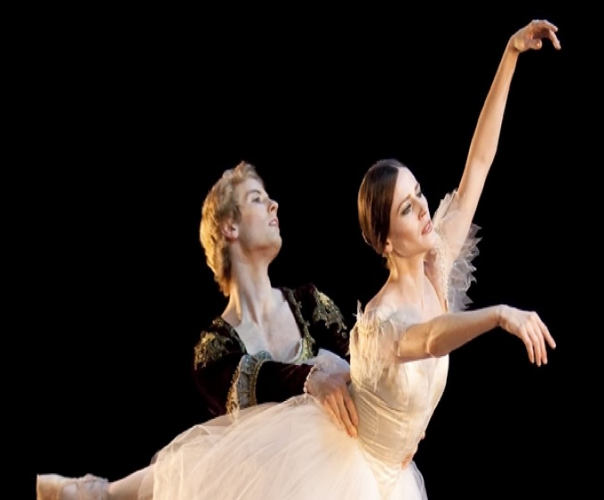
MEET STEVEN MCMAHON:
Associate Artistic Director has created more than a dozen ballets for Ballet Memphis, including his first full-length ballet, Wizard of Oz as well as Soul Selects Her Own Society, Confluence, The Royal We and Peter Pan. His other new ballets for Ballet Memphis include Carnival of the Animals, Romeo and Juliet and Cinderella. Steven also has choreographed many original works including The Lovely Story of Us, which was performed in Helsinki, Finland, at the International Ballet Competition, and two of his works, Being Here With Other People and Confluence, have been performed at the Spring to Dance Festival in St. Louis. His works have been performed at Organizacion Para La Artes in Guatemala and at other venues around the nation. His first work, What Your Soul Sings, premiered at Ballet Memphis’ Interiorworks. Steven, who is originally from Glasgow, Scotland, is also a dancer with Ballet Memphis and joined after completing his training at The Ailey School in New York City.

How well do you know the story Giselle?
- The original ballet takes place in 1841 in which if the following countries?
Italy France Germany Sweden

- Giselle ou Les Wilis premiered at the Paris Opera on June 28, 1841 with _____________ as Giselle?
Carlotta Grisi Misty Copeland Martha Graham Jasmine Perry

- Giselle is one of the first full length ballets to be performed on pointe.
True False

- The second act is commonly referred to as the “White Act”, can you explain why?

- How many seasons have Ballet Memphis performed Giselle?
1 2 3 4

Answer Key: 1. France 2. Carlotta Grisi 3. True 4. The case with Giselle, the White Act also gives the lovers a chance to say one last goodbye. 5. 2 seasons

GISELLE SYNOPSIS

Act I
A small, peaceful village, bathed in sunlight. It is inhabited by simple, artless people. Giselle, a young peasant girl, is rejoicing in the sun, the blue sky, the singing of the birds and, most of all, in the happiness of pure, trusting love which has lit up her life. She is in love and is confident that she is loved. The gamekeeper, who is in love with Giselle, tries in vain to persuade her that Albrecht, her loved one, is not a peasant at all but a nobleman in disguise and that he is deceiving her.
The gamekeeper manages to steal into the cottage which Albrecht is renting in the village and here he finds a silver sword with a coat of arms on it. Now the gamekeeper knows for sure that Albrechtis concealing his noble origins.
A party of distinguished noblemen, attended by a sumptuous suite, seek rest and refreshment in the village after the hunt. The peasants give their guests a cordial welcome.
Albrecht is embarrassed by this unexpected meeting: he tries to hide the fact he knows them for, in their company, is his betrothed, Bathilde. Meanwhile the gamekeeper shows everyone Albrecht’s sword and, unmasking him, tells them of the latter’s deceit. Giselle is shocked to the core by the perfidy of her loved one. The pure, crystal-clear world of her faith, hopes and dreams has been destroyed.She goes mad and dies.
Act II
Night-time. The ghostly forms of the Wilis, died brides, appear among the graves of the village church yard which is bathed in moonlight. “Dressed inbridal gowns and garlands of flowers...The irresistibly beautiful Wilis danced to the light of the moon. And as they felt the time given them for dancing was running out and that they had again toreturn to their icy graves, their dancing became more and more impassioned and rapid...” (Heinrich Heine).
The Wilis catch sight of the gamekeeper who, suffering from pangs of conscience, has come to visit Giselle’s grave. At the command of Myrtha, the unrelenting Queen of the Wilis, the Wilis encirclethe gamekeeper and make him dance until he drops lifeless, to the ground.
Albrecht too, is unable to forget Giselle. And, at dead of night, he comes to her grave. The Wilis immediately encircle the youth. Albrecht is now threatened by the same horrifying fate as the gamekeeper. But the shadow of Giselle now appears and her eternal and self-sacrificing love protects and saves Albrecht from the anger of the Wilis.
The ghostly, white forms of the Wilis vanish with the first rays of the rising sun. And Giselle’s ethereal shadow vanishes too, but Giselle will always be alive in Albrecht’s memory — theever-present regret for a lost love, a love that is stronger than death.

After attending the ballet:
INTERACT WITH COMPANY

WRITE A REVIEW:
What were some of the memorable moments in the ballet that caught your attention? How were the characters portrayed through dance? How did the music enhance the performance?
SUBMIT A VIDEO:
They enjoyed hearing from the audience. Showcase your favorite act of the performance by submitting your choreography. Recreate your own version of Giselle.
Note to instructor: I would discourage students from performing any lifts in their choreography to avoid injury.
Video submission must be submitted via google drive to nlewis@balletmemphis.org.

*Full curriculum upon request*
Nikki Lewis 901.214.2407
nlewis@balletmemphis.org
Visit our web page at:
www.balletmemphis.org

Before coming to the performance:
READ THE STORY
In classical ballet the story is told through movement, and clearly tells the story it is always best to be familiar with the plot. A synopsis of the story is found on page 3 of this guidebook (you may use guidebook or any version of Giselle to help you complete the activity below).

Activity 1
In groups of 3’s, share a story with your peers about love and lost. Have you ever been hurt by someone you loved? How did it make you feel? Were you ever able to forgive the person whom hurt you?
Think about the above questions and share your personal experiences with your peers. After each person has shared their story take the WORDS out of your story and replace words with MOVMENT!
Once you’ve begin creating movement, then each group must combine stories together and share with peers and instructor. You may add music from Giselle to support your stories.
Are there any similarities or differences in your personal stories and/or movement?

What did you learn about yourself?

Read the story:
T
E
A
C
H
I
N
G

A
C
T
I
V
I
T
I
E
S

In classical

