TEAM Lesson Plan Template
Teacher:
Class: 1st grade
Course Unit: ELA/ Reading Comprehension Skills
Lesson Title: Using our senses to create a mental picture
LESSON OVERVIEW | Summary of the task, challenge, investigation, career-related scenario, problem, or community link.
We will be using the book Owl Moon to identify words that appeal to the 5 senses (see, hear, taste, smell, and feel). Students will then use the words that we identified to create a mental image of the text. Students will show mastery by identifying and categorizing words that appeal to the senses from a piece of text, in which they will then create a visual image.
STANDARDS | Identify what you want to teach. Reference State, Common Core, ACT College Readiness Standards and/or State Competencies.
CCSS.ELA – Literacy.RL.1.4 Identify words and phrases in stories or poems that suggest feelings or appeal to the senses.
OBJECTIVE | Clear, Specific, and Measurable – NOT ACTIVITIES  Student-Friendly
I will be able to identify words from a story, Owl Moon, that appeal to my 5 senses, in order to help me create a mental picture.
ASSESSMENT/EVALUATION | Students show evidence of proficiency through a variety of assessments.  Aligned with the Lesson Objective  Formative/Summative  Performance-Based/Rubric  Formal/Informal
-Students will be informally assessed through teacher observation during partner work. I will walk around the room to see which students are participating and making contributions to the assignment.

-Informal assessment by the teacher during group discussion – I will be asking questions to see the level of understanding. I will be observing to see the level of thinking from the beginning of the lesson to the close of the lesson.

-Independent formal assessment – Students will turn in their independent work, in which they were given a differentiated piece of text to read and identify sensory words. They will have to sort and categorize the words according to which sense they used. Then, they will be asked to draw a picture that makes a connection to the sensory words they found in the text.

-Ticket-out-the-door formal assessment – Students will have to read a short sentence and identify and sensory words, classify which of the senses they used, and answer the essential question from the lesson.

-Informal assessment – During the closure, I will ask students to rate their own understanding from the lesson.

MATERIALS | Aligned with the Lesson Objective  Rigorous & Relevant
Smartboard/ projector (notebook file)
Book: Owl Moon by Jane Yolen
Pencils/ crayons
Ticket-out-the-door sheet
5 senses visualizing sheet for partner work
independent work
short video clips
ACTIVATING STRATEGY | Motivator/Hook  An Essential Question encourages students to put forth more effort when faced with a complex, open-ended, challenging, meaningful and authentic questions.
We will start the lesson on the carpet as a whole group. The essential question that I want the students to answer is, “Why is it important for us to identify sensory words while we are reading?” I will ask this question at the beginning of the lesson, after stating the lesson objective. I will see what kind of responses and ideas the students have. After the discussion, I will show a quick video clip on visualizing/inferencing. Then, I will give the students a scenario, in which they will be asked to identify any words or phrases that appeal to their senses. The scenario will be a short video clip, which is a Hershey’s syrup commercial. After the video, have a discussion about the sensory words (sounds) that were recognized. Ask the students why the commercial was created the way it was. Then, after a discussion about the appeal of the senses, ask the original essential question again to see if the students have a better understanding of what it means to use our senses and why we would do this in our reading.
INSTRUCTION | Step-by-Step Procedures-Sequence  Discover/Explain – Direct Instruction  Modeling Expectations – “I Do”  Questioning/Encourages Higher Order Thinking  Grouping Strategies  Differentiated Instructional Strategies to Provide Intervention & Extension
Teacher: We have listened to the story Owl Moon. We have not seen the illustrations from the story yet because we are going to use our senses to help us create a picture in our mind. We will come up with our own illustrations for the story. Later in the week, we will look at the actual illustrations from the book to see if our personal illustrations match those of the illustrator. As a class, we will quickly review what they story was about and the 5 senses (see, hear, taste, smell, and feel).

Displayed on the SmartBoard, I will have the text from one of the pages in the story Owl Moon (page 5, smartboard slide 5). There will be no pictures and the students have not previously seen the illustrations from the book. Since we have previously read the book, I will remind students what part of the book this piece of text comes from. I will ask the students to follow along as I read the text and do a think-aloud for them to see me identify words that appeal to my senses. As I am doing this, I will be sorting and categorizing the sensory words according to which sense it appeals to. Throughout this think-aloud, I will be modeling my thinking process and explaining how I know which words are important and how I know which words appeal to the senses. I will also be explaining why I am identifying these words from the text (these sensory words help me be a better reader because it helps me create a picture in my mind that will allow me to understand the text better). I will draw a picture to show how I can use sensory words to create a mental image/ picture.
GUIDED & INDEPENDENT PRACTICE | “We Do”-“You Do”  Encourage Higher Order Thinking & Problem Solving  Relevance  Differentiated Strategies for Practice to Provide Intervention & Extension
Guided practice: Let’s remember that our goal for the day is to read a piece of text and identify words that appeal to our senses. You are going to get another piece of text from Owl Moon, in which you are going to work with a partner to do like what I just showed you (smartboard slide 6 is the partner work sheet). We will all read the piece of text together. Partners will reread the text and then be asked to work together to identify words that appeal to their senses. They will have to identify the relevant information because not all words will appeal to one of the senses. Partners will be groups by ability level. Students will draw a picture that matches the image that came to mind when reading the sensory words.

We will come back together on the carpet for a quick share time. I will choose 2-3 pieces of work from partners to share with the whole group. I will ask the rest of the class some questions about the shared work. (Even though everyone read the same piece of text, did we all come up with the same sensory words?) (Do you believe our illustrations will match those of the illustrator? Why or why not?)

The students will now have independent work (see below for below, on-level, and above). They will be given another piece of text from the story. Everyone will have the same part from the story; however, I will differentiate for ability levels by giving the students different lengths of text. The lowest ability level students will have one sentence from the story, in which they must read and identify what sensory words they see. They will then draw a picture. The on-level students will have three sentences. The highest ability students will have five sentences.

CLOSURE | Reflection/Wrap-Up  Summarizing, Reminding, Reflecting, Restating, Connecting
We will restate the objective and review what we learned in the lesson (smartboard slide 9). Students looked more closely at 3 different pieces of text from the story. Their goal was to identify words that appeal to the senses and create a mental picture. Students will be asked to identify how well they think they accomplished this goal by raising 1, 2 or 3 fingers for how they felt about meeting the objective. The guidelines for 1,2, or 3 fingers will be explained on the SmartBoard (smartboard slide 10). (I would like for each of you to rate your understanding of the lesson. I want everyone to hold up fingers to let me know how you feel about this lesson. If you understood how to identify the sensory words and you were able to create a mental picture, hold up a 1. If you feel okay with the lesson – you sort of understand, but could use more practice, hold up a 2. If you feel like you did not understand what you were doing and need some more help, hold up a 3. I want everyone to close your eyes, so that only I will know).

Students will be given one last assessment (ticket-out-the-door – smartboard slide 11). I am going to give students a sentence and they will identify any words in the sentence that appeals to one of the five senses. Students will tell me which sense it appeals to. They will answer the question, “Why is it important to use our senses when reading?” As students finish their assessment, they will be asked to go back and finish their independent work.

CROSS-CURRICULAR CONNECTIONS
Writing – we are using the story Owl Moon to learn about word choice in our writing

Arts – illustrations and images
NOTES:
~Before reading the story Owl Moon aloud to the students, discuss vocabulary that students might struggle to understand (smartboard slide 3).
~During reading, stop on each page or every other page and allow the students to share out what they hear, see, smell, taste, or feel. Record what they say on smartboard slide 4, so that they will be able to recall the story later. (On a side note, you may have to discuss what it means to feel – do you want them to feel with their hands or with their hearts –feelings).

Name: _____________________________

Read the sentence below. Choose any words that appeal to your senses and write them next to that sense.
We went into the quiet woods.
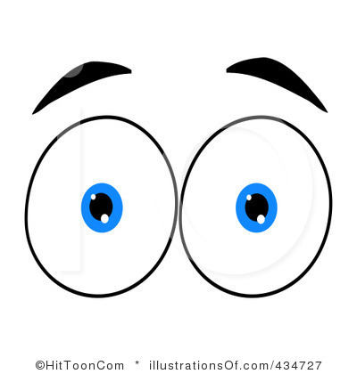See-
Smell-
Taste-
Feel-
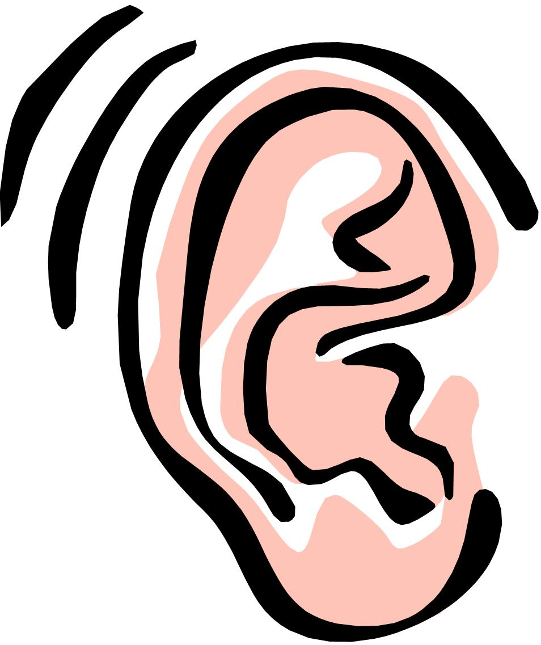Hear-

Draw a picture to go with the sensory words you identified.
Name: _____________________________

Read the sentence below. Choose any words that appeal to your senses and write them next to that sense.
We went into the quiet woods. The shadows were the blackest things I had ever seen. They stained the white snow.
See-
Smell-
Taste-
Feel-
Hear-

Draw a picture to go with the sensory words you identified.
Name: _____________________________
Read the sentence below. Choose any words that appeal to your senses and write them next to that sense.
We went into the quiet woods. The shadows were the blackest things I had ever seen. They stained the white snow. My mouth felt furry, for the scarf over it was warm. I didn’t ask what kinds of things hide behind black trees in the middle of the night.
See-
Smell-
Taste-
Feel-
Hear-

Draw a picture to go with the sensory words you identified.

