TEAM Lesson Plan Template
Teacher:
Class: 1st grade
Course Unit: ELA/ Arts
Lesson Title: Visualizing/ Using our senses with Owl Moon
LESSON OVERVIEW | Summary of the task, challenge, investigation, career-related scenario, problem, or community link.
The students will use what they know about visualizing/ using their 5 senses, and will incorporate what they learn about the art techniques and elements of art (colors, space, and value) to create a piece of original artwork and writing, based off the story Owl Moon.
STANDARDS | Identify what you want to teach. Reference State, Common Core, ACT College Readiness Standards and/or State Competencies.
CCSS.ELA – Literacy.RL.1.4 Identify words and phrases in stories or poems that suggest feelings or appeal to the senses.
Arts GLE 1.2: Students will demonstrate an understanding of a variety of techniques.
Arts GLE 2.1 Students will demonstrate developmentally appropriate knowledge of the elements of art.
- Arts SPI 2.1.1: Students will be able to name and describe examples of lines, shapes, colors, textures, value, form, and space.

OBJECTIVE | Clear, Specific, and Measurable – NOT ACTIVITIES  Student-Friendly
I will be able to listen to the text, Owl Moon, and visualize the story by using what I know about words that appeal to my 5 senses.

I will be able to create a painting that shows the visualization in my mind of the text, Owl Moon, using the art techniques of colors, space, and value.

ASSESSMENT/EVALUATION | Students show evidence of proficiency through a variety of assessments.  Aligned with the Lesson Objective  Formative/Summative  Performance-Based/Rubric  Formal/Informal
-Whole group assessment through visualization activity/ share-out (ELA portion – smartboard slides 4-5) (assess individual students informally by having them give thumbs up or by using body motions according to which sense appeals to them…..for example, have students cup their ears if the text appeals to their hearing).
-Question and answer time
-Owl Moon painting (assessed based off of a rubric-see attached)
-1:1 conversations while patrolling the classroom (listening for use of art vocabulary, watching for techniques, monitoring their understanding of how they connect to their senses, while also knowing the reasons behind why they use the cool colors, the tints and shades, and the techniques of colors, space, and value).
-Tints and shades practice activity (landscapes or flower)
-Student explanation of their Owl Moon painting (students should be asked to explain their colors, objects, space, etc. and why they incorporated it into their artwork) – They could be asked to do a writing piece or if technology is available, they could use an iPad to record a video of their painting while also talking/ presenting a think aloud that explains their reasoning for the choices they made in their painting.

MATERIALS | Aligned with the Lesson Objective  Rigorous & Relevant
Book: Owl Moon by Jane Yolen
White construction paper for paintings
Paint – cool colors and whites/blacks
Paint brushes
Variety of construction paper for moon and other possible objects (limit the amount so that the whole artwork is not construction paper – they should use very little)
Smart board doc on visualization/senses and art strategies needed (cool colors, tints and shades)
Tints and shades practice page activity
Rubrics
ACTIVATING STRATEGY | Motivator/Hook  An Essential Question encourages students to put forth more effort when faced with a complex, open-ended, challenging, meaningful and authentic questions.
Show some examples of paintings to students and ask them about the picture – what do they notice, wonder, etc. Also, ask them where they think the picture came from? How did the artist decide on colors, values, and space? (smartboard slides 14-15)

Explain to students that they will be hearing a story called Owl Moon; however, they will not be seeing any illustrations. Only knowing the title, ask students to use the critical protocol:
I notice…
I wonder…
I speculate…

Teacher: Today our goal is to use our 5 senses that we have learned about to help us visualize and create a mental picture of Owl Moon by only hearing the text read aloud. We will each end up with a picture that shows our own mental image of Owl Moon.
Allow this to lead you into the art presentation and instruction on the smart board.
INSTRUCTION | Step-by-Step Procedures-Sequence  Discover/Explain – Direct Instruction  Modeling Expectations – “I Do”  Questioning/Encourages Higher Order Thinking  Grouping Strategies  Differentiated Instructional Strategies to Provide Intervention & Extension
See other lesson plan to know what came before the arts integrated part of the lesson – read the text aloud, model, and discuss the goal.

Day 1 of art:
- See if students know what cool colors are. Listen to responses. Show the smartboard doc (slide 17). It explains that cool colors are mostly greens, blues, and purples because these are colors that remind people of cool things like a cool forest or a cold lake.
- On the next slide, students will see a painting by Claude Monet and asked what cool colors they notice and how the painting makes them feel? Then have a discussion about a variety of colors and how they express and show different feelings.
- Once students know about cool colors, they should be instructed to listen to the text again (this can be done through another whole group read-aloud… or through ipads/ voice recorders if available, which is an excellent option because it allows the students to go at their own pace and play-pause the story when needed to take notes --- a note taking page is located on slide 13 of the smartboard file, if needed)
- As students are listening to the story a second time through, they should be taking notes on the 5 senses chart (slide 13). They will sort the words in the story that have appealed to their senses (sight, touch, taste, smell, and sound). This chart will be used to help them once they are ready for their Owl Moon painting.

Day 2 of art:
- See if students know what hues, tints and shades are. Listen to responses. Review the smartboard slide (slide 20-25), which explains what hues, tints and shades are. It will also allow the students to have some practice with the vocabulary and checking for understanding, and then some practice with mixing hues with tints and shades. Explain that we will use tints and shades to help show the different levels of our background (from the forest floor -darker to the nighttime sky –lighter with moonlight).

GUIDED & INDEPENDENT PRACTICE | “We Do”-“You Do”  Encourage Higher Order Thinking & Problem Solving  Relevance  Differentiated Strategies for Practice to Provide Intervention & Extension
- As a whole group, discuss what colors should go into the Owl Moon painting and reasons why we think it should have these colors – Discuss why it should be cool colors (winter – cold, snow; night – dark, moonlight)
- Show students an example of an Owl Moon painting and model a think-aloud that explains the painting and reasons why colors/objects were chosen for the picture. (Ex. Explain to students that the bottom is darker because it represents the forest floor and the top is lighter because it represents the nighttime sky with the moonlight – the students will learn about tints and shades a little later in the lesson, so they will understand how to show darkness and lightness)
- Model for students on a sheet of paper how to blend colors by using parallel brush strokes and overlapping the color before and after to help with creating multiple shades of each color along with a subtle blend into the next color.
- Allow students to paint the background for their painting based on what they visualized in their mind (nighttime sky, forest floor, trees, snow, etc), remembering to use cool colors.

Day 2 of art:

-Allow students to practice tints and shades before painting on their Owl Moon background. (see the notes section below for a couple of different ideas – landscape or flower petals…..the flower is quick and easy).
Ask questions to students about tinting and shading: Can you see how painting tints and shades makes a painting have different moods or feelings?
-As the painting is drying, the students can start to add in objects from the story, such as the trees, snow, moon, owl, etc.
-If enough time is left and you want to go a little deeper, you could introduce what a silhouette (connect it to the art element of showing space) is. The owl or tree limbs could be painted in front of the moon (made out of construction paper to show depth better.

CLOSURE | Reflection/Wrap-Up  Summarizing, Reminding, Reflecting, Restating, Connecting
Come back together as a whole group. Have a student restate their reading and art goal. Explain how we accomplished it. Ask students to share their painting if time is available. Are the paintings all the same? Are they different? Why? What difference does it make?

CROSS-CURRICULAR CONNECTIONS
Speaking and listening skills in small group

ELA/ Science – using senses/ words that appeal to our feelings
NOTES:
This is a multi-day lesson. I taught it over the course of a week. The painting takes at least 2 class periods. Before the painting can begin, the students listen to the story Owl Moon being read aloud (see the attached ELA team lesson plan for more specific ELA focus - How to use the 5 different senses when creating a mental picture). They should be instructed to close their eyes and create a mental picture in their minds as they hear the words. It should be modeled on the smartboard document how to visualize/create a mental picture

Previous knowledge/ other lessons within the week that need to be taught/practiced:
~tinting and shading practice (before doing tints and shades on real Owl Moon painting, allow them some practice, possibly a landscape tints and shades mini lesson, in which they use one color throughout the landscape……ex. 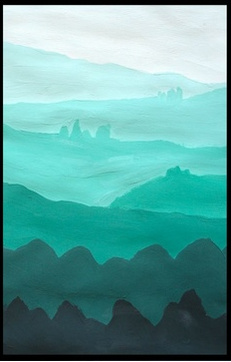 or something similar to the flower petals handout….
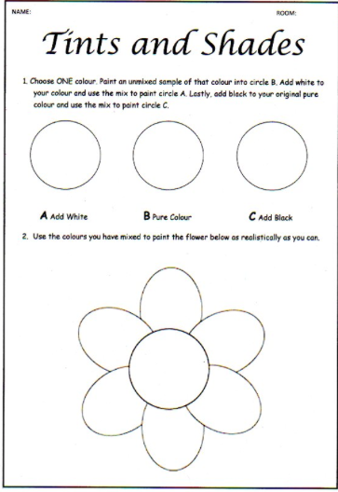 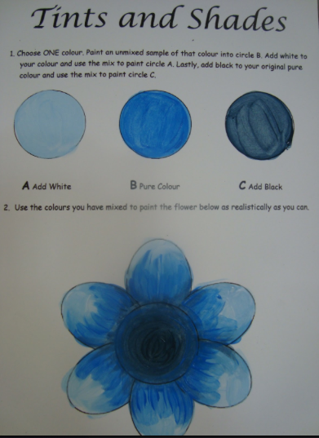 )

Rubric for Owl Moon painting:
 | Exceeds | Meets | Progressing | Unsatisfactory
Followed Directions
Used creativity
Use of space
Use of colors (cool colors, value of colors)
Includes details from Owl Moon

